**NATURAL DISASTERS INTENSITY ANALYSIS AND CLASSIFICATION USING ARTIFICIAL INTELLIGENCE**

**ABSTRACT**

Natural disasters are inevitable, and the occurrence of disasters drastically affects the economy, ecosystem and human life. Buildings collapse, ailments spread and sometimes natural disasters such as tsunamis, earthquakes, and forest fires can devastate nations. When earthquakes occur, millions of buildings collapse due to seismological effects. Not only disturb the human ecological system but also destroy the properties and critical infrastructures of human societies and even lead to permanent change in the ecosystem. Disaster can be caused by naturally occurring events such as earthquakes, cyclones, floods, and wildfires. Many deep learning techniques have been applied by various researchers to detect and classify natural disasters to overcome losses in ecosystems, but detection of natural disasters still faces issues due to the complex and imbalanced structures of images. To tackle this problem, we developed a multilayered deep convolutional neural network (CNN) model that classifies the natural disaster and tells the intensity of disaster of natural model uses an integrated webcam to capture the video frame and the video frame is compared with the Pre-trained model and the type of disaster is identified and showcased on the OpenCV window.

1. **INTRODUCTION**
   1. **PROJECT OVERVIEW**

As the population is growing rapidly, people need to acquire land to live on, and as a result the ecosystem is disturbed horrifically, which causes global warming and increases the number of natural disasters. Populations in underdeveloped countries cannot afford damages disasters cause to infrastructures. The aftermath of disasters leaves the humans in miserable situations, and sometimes the devastating effects cannot be detected; additionally, rescue operations cannot take place in most of the places and victims are unable to be identified due to geographical factors of the different areas. Disasters spread rapidly in dense areas, difficult to carry out; in this case, development of the strategy to predict such circumstances is crucial so that such disasters can be prevented beforehand. Data acquired helps to identify the intensity of the situation in a post disaster scenario. It helps to take actions and carry out necessary operations to tackle devastating scenarios. Raw images obtained from camera-equipped are processed and neural network-based feature extraction techniques are applied to analyze the intensity of the disaster.

* 1. **PURPOSE**

Disasters are difficult to carry out and spread quickly in dense places; in this situation, it is essential to establish a plan to anticipate these conditions so that disasters can be avoided in advance. Data collection aids in determining the severity of the issue in the aftermath of a disaster. To deal with disastrous situations, it helps to take action and conduct the required procedures. To determine the disaster's intensity, raw photos from cameras are processed and neural network-based feature extraction methods are used.

1. **LITERATURE REVIEW**
   1. **EXISTING PROBLEM**

**2.1.1 TITLE: Development of Model to Predict the Natural Disaster Induced Financial Loses For Construction Projects Using Deep Learning**

**AUTHOR NAME: Ji-Myong Kim**

In order to lessen and prevent the risk of financial loss at construction sites, this project aims to develop a model for forecasting financial loss there using a deep learning algorithm. Recently, the severity and frequency of accidents occurring at construction sites are growing, and financial losses are also escalating. This is due to the development of high-rise buildings and complicated constructions, as well as an increase in the size of construction sites. The risk of financial loss for construction sites is growing specifically as the frequency of natural disasters and the number of urban construction projects rise. A financial loss prediction model is therefore needed for managing and maintaining the risk of such financial loss in building project management. This study uses data on claim payouts from a significant South Korean insurance firm to show the monetary losses sustained at the real building sites. An objective and accurate prediction model was created using a deep learning algorithm. The findings and framework of this study serve as a guide for various other construction project management studies and offer crucial advice on managing financial losses required for long-term sustainability and project success.

**2.1.2 TITLE: Remote Sensing Methods for Flood Prediction: A Review, 2022**

**AUTHOR NAME: Hafiz Suliman Munawar**

Floods are a major cause of loss of lives, destruction of infrastructure, and massive damage to a country’s economy. Floods, being natural disasters, cannot be prevented completely; therefore, precautionary measures must be taken by the government, concerned organizations such as the United Nations Office for Disaster Risk Reduction and Office for the coordination of Human Affairs, and the community to control its disastrous effects. To minimize hazards and to provide an emergency response at the time of natural calamity, various measures must be taken by the disaster management authorities before the flood incident. This involves the use of the latest cutting-edge technologies which predict the occurrence of disaster as early as possible such that proper response strategies can be adopted before the disaster. Floods are uncertain depending on several climatic and environmental factors, and therefore are difficult to predict. Hence, improvement in the adoption of the latest technology to move towards automated disaster prediction and forecasting is a must. This study reviews the adoption of remote sensing methods for predicting floods and thus focuses on the pre-disaster phase of the disaster management process for the past 20 years. A classification framework is presented which classifies the remote sensing technologies being used for flood prediction into three types, which are: multispectral, radar, and light detection and ranging (LIDAR). Further categorization is performed based on the method used for data analysis. The technologies are examined based on their relevance to flood prediction, flood risk assessment, and hazard analysis. Some gaps and limitations present in each of the reviewed technologies have been identified. A flood prediction and extent mapping model are then proposed to overcome the current gaps. The compiled results demonstrate the state of each technology’s practice and usage in flood prediction.

**2.1.3 TITLE: Construction of Urban Flood Disaster Emergency Management System Using Scenario Construction Technology, 2022**

**AUTHOR NAME: Xianghai L**

Due to the global climate anomaly, ecological environment damage, human activities, and other reasons, flood disaster has become a major threat to mankind. )e emergency rescue resources under different subject management and different emergencies have different characteristics, attributes, and management modes, which restrict the unified dispatching, overall management, and efficient utilization of the comprehensive rescue command platform. )e frequent occurrence of natural disasters can not only easily affect the public security of society but also pose a great threat to the safety of Chinese people’s lives and property. As the first-line person in charge of China’s response to natural disasters, local governments cannot deal with natural disasters well. More than thousands of people die from natural disasters in China every year. )e economic losses caused amounted to hundreds of billions. )e occurrence of various floods and natural disasters not only affects the local economic and social development but also relates to the production and life of the local people, and the stability of the local society and national unity. How to effectively deal with flood disaster is also an important index system to test the execution and management ability of the Party and the government. )erefore, it is necessary to deeply study flood disaster from the theoretical height, hoping to provide reference theoretical support and practical guidance for local county-level government flood disaster emergency management.

**2.1.4 TITLE: Remote Sensing And Its Application in Disaster Management In India, 2022**

**AUTHOR NAME: Dr. Uday N. Suryawanshi**

Application of remote sensing is well development advanced technology in Geography. This technology is useful the natural and manmade disaster management. Today Impact of natural disasters on life and property and ability to predict them would be one of the main contributions of remote sensing technology. Involving remote sensing with GIS and GPS technology makes it an extremely powerful tool to identify indicators of potential disasters. Information sharing through internet reduces data acquisition time and thus providing efficient way to carry out real time disaster predictions (floods, forest, fire, tsunami and hurricane etc.) Changing land use and assessment of its impact on the system in general within reasonable time frame and with greater degree of accuracy becomes possible with new technology. Remote sensing is a revolutionary tool that can be used for obtaining information an object by observing it from a distance and without coming into actual contact with it. In fact, when we see an object and understand what it is, our eye is sensing that object remotely. This is a broad definition but we generally use this term for observing our earth’s surface from space using satellites or from the air using aircraft which have been modified suitably.

**2.1.5 TITLE: The effect of economic variables on natural disasters and the impact of disasters on economic variables**

**AUTHOR NAME: Evi Susanti Tasri**

This study aims to study how disaster losses are affected by unemployment and poverty, then how disasters also cause income inequality in Indonesia and the causal relationship between disaster losses and income inequality. To determine the structural relationship between economic variables and disaster losses, the Structural Equation Model-Partial Least Squares (SEM - PLS) approach is used. This approach is an approach previously not found in economic and environmental studies. This study uses secondary data consisting of 30 years 1990–2019 collected from the territory of Indonesia. The results of the study found that unemployment and poverty variables had a significant effect on the disaster loss variable. The disaster loss variable has a significant effect on the income inequality variable. The income inequality variable has no effect on the disaster loss variable. Research is expected to contribute to the study of the impact of economic development and the environment. The study of whether natural disasters are a real obstacle to the growth and economic development of a country is a study that is being carried out by many experts, considering that natural disasters are unpredictable events but have a real impact on the economy. A disaster in an area will have an impact on economic losses, among others, in the form of infrastructure damage in the area where the disaster occurred. Studies on disasters conducted by many experts have found that disasters with the category of disasters that occur suddenly (hurricanes, earthquakes, floods) will damage productive capital and infrastructure. Different things happen to disasters categorized as disasters that occur slowly (drought and floods) where these disasters have a wider and long-term impact.

* 1. **REFERENCES**

[1]. Ji-Myong Kim Development of Model to Predict the Natural Disaster Induced Financial Loses For Construction Projects Using Deep Learning

[2]. Hafiz Suliman Munawar, Remote Sensing Methods for Flood Prediction: A Review, 2022

[3]. Xianghai L, Construction of Urban Flood Disaster Emergency Management System Using Scenario Construction Technology, 2022

[4]. Dr. Uday N. Suryawanshi, Remote Sensing And Its Application in Disaster Management In India, 2022

[5]. Evi Susanti Tasri, The effect of economic variables on natural disasters and the impact of disasters on economic variables, 2022

* 1. **PROBLEM STATEMENT DEFINITION**

In existing system, use of manpower is difficult in case of natural disaster occurrence in hilly areas, and continuous electric power supply is highly affected in these areas due to maintenance issues of transmission lines. Therefore, in this case autopilot aerial equipment is used to gather images, and hidden content from aerial images needs to be identified in case of natural disasters such as landslides and heavy snowfall. Populations in underdeveloped countries cannot afford damages disasters cause to infrastructures. The aftermath of disasters leaves the humans in miserable situations, and sometimes the devastating effects cannot be detected; additionally, rescue operations cannot take place in most of the places and victims are unable to be identified due to geographical factors of the different areas.

1. **IDEATION & PROPOSED SOLUTION**
   1. **EMPATHY MAP CANVAS**

* 1. **IDEATION & BRAINSTORMING**
  2. **PROPOSED SOLUTION**

Natural disaster intensity analysis and classification based on multispectral images using a multilayered deep convolutional neural network. Moreover, this method consists of two blocks of a convolutional neural network. The first block detects a natural disaster occurring and the second one defines the intensity type of the natural disaster. Additionally, the first block consists of three mini convolutional blocks with four layers each, including an image input and fully connected layers. On the other hand, the second block also consists of three mini convolutional blocks with two layers each and includes an image input layer and fully connected layer. To evaluate the performance of the proposed multilayered deep convolutional neural network uses a train–test validation schema. To train the whole model, the training dataset was used, while for the fine-tuning of model the validation set was used. The performance of the whole framework was calculated on the basis of the test dataset. The proposed model works on an image dataset to detect and classify the natural disasters.

* 1. **PROBLEM SOLUTION FIT**

There isn't a methodical approach to swiftly become alert and announce the disaster. The frames from the CCTV camera are compared to the pre-trained data. When the statistics are matched, an alert is sent to the response team, who then informs the general public. The proposed system should enable offline and online communication between the system and the response team.

1. **REQUIREMENT ANALYSIS**
   1. **FUNCTIONAL REQUIREMENT**

**Upload Images**

In this module, we can upload the image or videos dataset to the system. The CCTV footage is used to capture the natural disaster image, but it has an increasing range of time resolution and space. Additionally, the information is kept in a database for later use. The dataset includes symptoms of disaster such as Cyclone, Earthquake, Tsunami, Fire Accidents, and Flood. These disasters symptoms are preserved as image or video and acquired from the Kaggle website.

**Noise Filtering**

By using filter techniques to minimise noise in image or video frames, it is possible to identify the signs of a natural disaster. The filter's objective is to eliminate noise, which degrades the appearance of images. This claim is supported by statistics. The usual frequency response of a filter is built. To remove "salt and pepper" noise, image processing often uses the nonlinear approach of filtering. A median filter is preferred than convolution when edge preservation and noise reduction are the primary considerations. Similar to photo binarization practise, document picture binarization is a technique used in the pre-processing phase of document analysis to distinguish the text in the foreground from the background of the document. A speedy and accurate binarization strategy is needed for the following document image processing activities.

**Classification**

Classification is the process of dividing data into various categories. The method starts by determining the class of the given data points. Classification is achievable for both structured and unstructured data. The terms target, label, and classes are occasionally used to describe the classes. The frames captured by the CCTV footage will be compared to the trained dataset in the system database for the features obtained in the feature extraction stage in the classification process. The specific image will be recognised once the ideal match is discovered based on the symptoms matched. The detected disaster name with its type will be displayed over the image. Here, a convolution neural network approach is employed to classify data.

**Disaster Detection**

The classification is the final step of the system. After analyzing the structure, each section individually evaluated for the probability of true positives. The CNN varies in how the convolutional and max pooling layers are realized and how the nets are trained. Finally classify the image regions using deep learning algorithm and improve the accuracy in classification. In this module, the system receives the image after the model has identified the disaster and extracts its types. And the responsive team will receive a warning message to protect the surrounding and alert people.

**Alert System**

The rapid growth of increasing the population and urbanization has led to the outbreak of disaster. Disaster is a natural hazard to the environment and the interference of the atmosphere system; the environment affects living organisms. In this module, send alert to the authority in terms of SMS at the time of fire detection. It can be useful to provide earlier detection.

* 1. **NON FUNCTIONAL REQUIREMENTS**

**Usability**

The system shall allow the users to access the system with pc using web application. The system uses a web application as an interface. The system is user friendly which makes the system easy

**Availability**

The system is available 100% for the user and is used 24 hrs a day and 365 days a year. The system shall be operational 24 hours a day and 7 days a week.

**Scalability**

Scalability is the measure of a system's ability to increase or decrease in performance and cost in response to changes in application and system processing demands.

**Security**

A security requirement is a statement of needed security functionality that ensures one of many different security properties of software is being satisfied.

**Performance**

The information is refreshed depending upon whether some updates have occurred or not in the application. The system shall respond to the member in not less than two seconds from the time of the request submittal. The system shall be allowed to take more time when doing large processing jobs. Responses to view information shall take no longer than 5 seconds to appear on the screen.

**Reliability**

The system has to be 100% reliable due to the importance of data and the damages that can be caused by incorrect or incomplete data. The system will run 7 days a week. 24 hours a day.

1. **PROJECT DESIGN**
   1. **DATA FLOW DIAGRAMS**

A two-dimensional diagram explains how data is processed and transferred in a system. The graphical depiction identifies each source of data and how it interacts with other data sources to reach a common output. Individuals seeking to draft a data flow diagram must identify external inputs and outputs, determine how the inputs and outputs relate to each other, and explain with graphics how these connections relate and what they result in. This type of diagram helps business development and design teams visualize how data is processed and identify or improve certain aspects.

**LEVEL 0**

The Level 0 DFD shows how the system is divided into 'sub-systems' (processes), each of which deals with one or more of the data flows to or from an external agent, and which together provide all of the functionality of the system as a whole. It also identifies internal data stores that must be present in order for the system to do its job, and shows the flow of data between the various parts of the system.

Trained Data

Stored on Database

**LEVEL 1**

The next stage is to create the Level 1 Data Flow Diagram. This highlights the main functions carried out by the system. As a rule, to describe the system was using between two and seven functions - two being a simple system and seven being a complicated system. This enables us to keep the model manageable on screen or paper.

Footage

Pre-processing

Noise Filtering

Feature Extraction

Extract Shape, Colour



**LEVEL 2**

A Data Flow Diagram (DFD) tracks processes and their data paths within the business or system boundary under investigation. A DFD defines each domain boundary and illustrates the logical movement and transformation of data within the defined boundary. The diagram shows 'what' input data enters the domain, 'what' logical processes the domain applies to that data, and 'what' output data leaves the domain. Essentially, a DFD is a tool for process modelling and one of the oldest.

Extracted Data

Matched with pre-trained data using BPNN

Performance Evaluation

* 1. **SOLUTION & TECHNICAL ARCHITECTURE**

A system architecture or systems architecture is the conceptual model that defines the structure, behavior, and more views of a system. An architecture description is a formal description and representation of a system, organized in a way that supports reasoning about the structures and behaviors of the system. System architecture can comprise system components, the externally visible properties of those components, the relationships (e.g. the behavior) between them. It can provide a plan from which products can be procured, and systems developed, that will work together to implement the overall system. There have been efforts to formalize languages to describe system architecture, collectively these are called architecture description languages (ADLs).

Trained Data

Pre-Processing

Noise Filtering

Feature Extraction

Extracting Shape, Color

Extracted Data

Classifying Using BPNN

Performance Evaluation



Footage



Server

* 1. **USER STORIES**

1. **PROJECT PLANNING & SCHEDULING**
   1. **SPRINT PLANNING & ESTIMATION**
   2. **SPRINT DELIVERY SCHEDULE**
   3. **REPORTS FROM JIRA**
2. **CODING & SOLUTIONING**
   1. **FEATURE 1**
   2. **FEATURE 2**
   3. **DATABASE SCHEMA**

1. **TESTING**
   1. **TEST CASES**

A test case has components that describe input, action and an expected response, in order to determine if a feature of an application is working correctly. A test case is a set of instructions on “HOW” to validate a particular test objective/target, which when followed will tell us if the expected behavior of the system is satisfied or not.

Characteristics of a good test case:

* Accurate: Exacts the purpose.
* Economical: No unnecessary steps or words.
* Traceable: Capable of being traced to requirements.
* Repeatable: Can be used to perform the test over and over.
* Reusable: Can be reused if necessary.

|  |  |  |  |  |
| --- | --- | --- | --- | --- |
| **S.NO** | **Scenario** | **Input** | **Excepted output** | **Actual output** |
| 1 | Admin | User name and password | Login | Login success. |
| 2 | Upload Dataset | Upload symptoms of disaster and its types as csv file | Upload successfully | Details stored in database. |
| 3 | CCTV footages | Predict and Classify the disaster and its types | Predict and classify the disaster and its types | Predicted successfully. |

* 1. **USER ACCEPTANCE TESTING**

This sort of testing is carried out by users, clients, or other authorised bodies to identify the requirements and operational procedures of an application or piece of software. The most crucial stage of testing is acceptance testing since it determines whether or not the customer will accept the application or programme. It could entail the application's U.I., performance, usability, and usefulness. It is also referred to as end-user testing, operational acceptance testing, and user acceptance testing (UAT).

1. **RESULTS**
   1. **PERFORMANCE METRICS**
2. **ADVANTAGES & DISADVANTAGES**

**ADVANTAGE**

• Automated analysis of natural disaster

• Reduce the time and computational complexity

• Relevant features are extraction

• Improved accuracy rate

**DISADVANTAGE**

**•** Manual analysis of natural disaster

• Need additional sensors to detect

• Time complexity is high

• Accuracy is less

1. **CONCLUSION**

The detection of natural disasters by using deep learning techniques still faces various issues due to noise and serious class imbalance problems. To address these problems, we proposed a multilayered deep convolutional neural network for detection and intensity classification of natural disasters. The proposed method works in two blocks—one for detection of natural disaster occurrence and the second block is used to remove imbalanced class issues. The proposed model achieved the highest accuracy as compared to other state-of-the-art methods due to its multilayered structure. The proposed model performs significantly better for natural disaster detection and classification, but in the future the model can be used for various natural disaster detection processes.

1. **FUTURE SCOPE**

However, if this model is run on a graphic processing unit (GPU)-based system in the future with real time sensors and monitoring power, then the proposed model will be used as a real time natural disaster detection model and provide some upcoming predictions for future disasters. The main purpose of this model is to detect and classify the type of disaster with a high accuracy rate. To prevent natural disasters in the future, said model can be used to predict future disasters and take some action against heavy loss of human ecological systems and property

1. **APPENDIX**

**SOURCE CODE**

import Flask, render_template, flash, request, session,send_file

from flask import render_template, redirect, url_for, request

import warnings

import datetime

import cv2

app = Flask(__name__)

app.config['DEBUG']

app.config['SECRET_KEY'] = '7d441f27d441f27567d441f2b6176a'

@app.route("/")

def homepage():

return render_template('index.html')

@app.route("/Training")

def Training():

return render_template('Tranning.html')

@app.route("/Test")

def Test():

return render_template('Test.html')

@app.route("/train", methods=['GET', 'POST'])

def train():

if request.method == 'POST':

import model as model

return render_template('Tranning.html')

@app.route("/testimage", methods=['GET', 'POST'])

def testimage():

if request.method == 'POST':

file = request.files['fileupload']

file.save('static/Out/Test.jpg')

img = cv2.imread('static/Out/Test.jpg')

if img is None:

print('no data')

img1 = cv2.imread('static/Out/Test.jpg')

print(img.shape)

img = cv2.resize(img, ((int)(img.shape[1] / 5), (int)(img.shape[0] / 5)))

original = img.copy()

neworiginal = img.copy()

cv2.imshow('original', img1)

gray = cv2.cvtColor(img1, cv2.COLOR_BGR2GRAY)

img1S = cv2.resize(img1, (960, 540))

cv2.imshow('Original image', img1S)

grayS = cv2.resize(gray, (960, 540))

cv2.imshow('Gray image', grayS)

gry = 'static/Out/gry.jpg'

cv2.imwrite(gry, grayS)

from PIL import ImageOps,Image

im = Image.open(file)

im_invert = ImageOps.invert(im)

inv = 'static/Out/inv.jpg'

im_invert.save(inv, quality=95)

dst = cv2.fastNlMeansDenoisingColored(img1, None, 10, 10, 7, 21)

cv2.imshow("Nosie Removal", dst)

noi = 'static/Out/noi.jpg'

cv2.imwrite(noi, dst)

import warnings

warnings.filterwarnings('ignore')

import tensorflow as tf

classifierLoad = tf.keras.models.load_model('firemodel.h5')

import numpy as np

from keras.preprocessing import image

test_image = image.load_img('static/Out/Test.jpg', target_size=(200, 200))

img1 = cv2.imread('static/Out/Test.jpg')

# test_image = image.img_to_array(test_image)

test_image = np.expand_dims(test_image, axis=0)

result = classifierLoad.predict(test_image)

out = ''

pre = ''

if result[0][0] == 1:

out = "Cyclone"

elif result[0][1] == 1:

out = "Earthquake"

elif result[0][2] == 1:

out = "Flood"

elif result[0][3] == 1:

out = "Wildfire"

org = 'static/Out/Test.jpg'

gry ='static/Out/gry.jpg'

inv = 'static/Out/inv.jpg'

noi = 'static/Out/noi.jpg'

return render_template('Test.html',result=out,org=org,gry=gry,inv=inv,noi=noi)

if __name__ == '__main__':

app.run(debug=True, use_reloader=True)

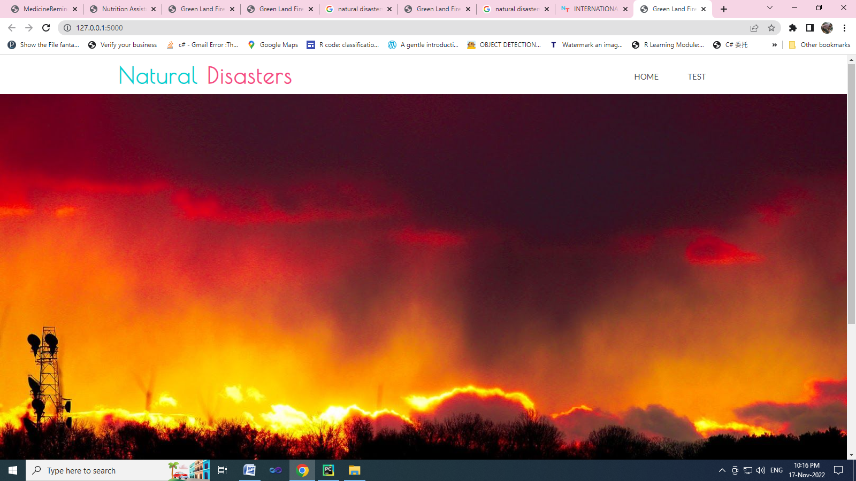





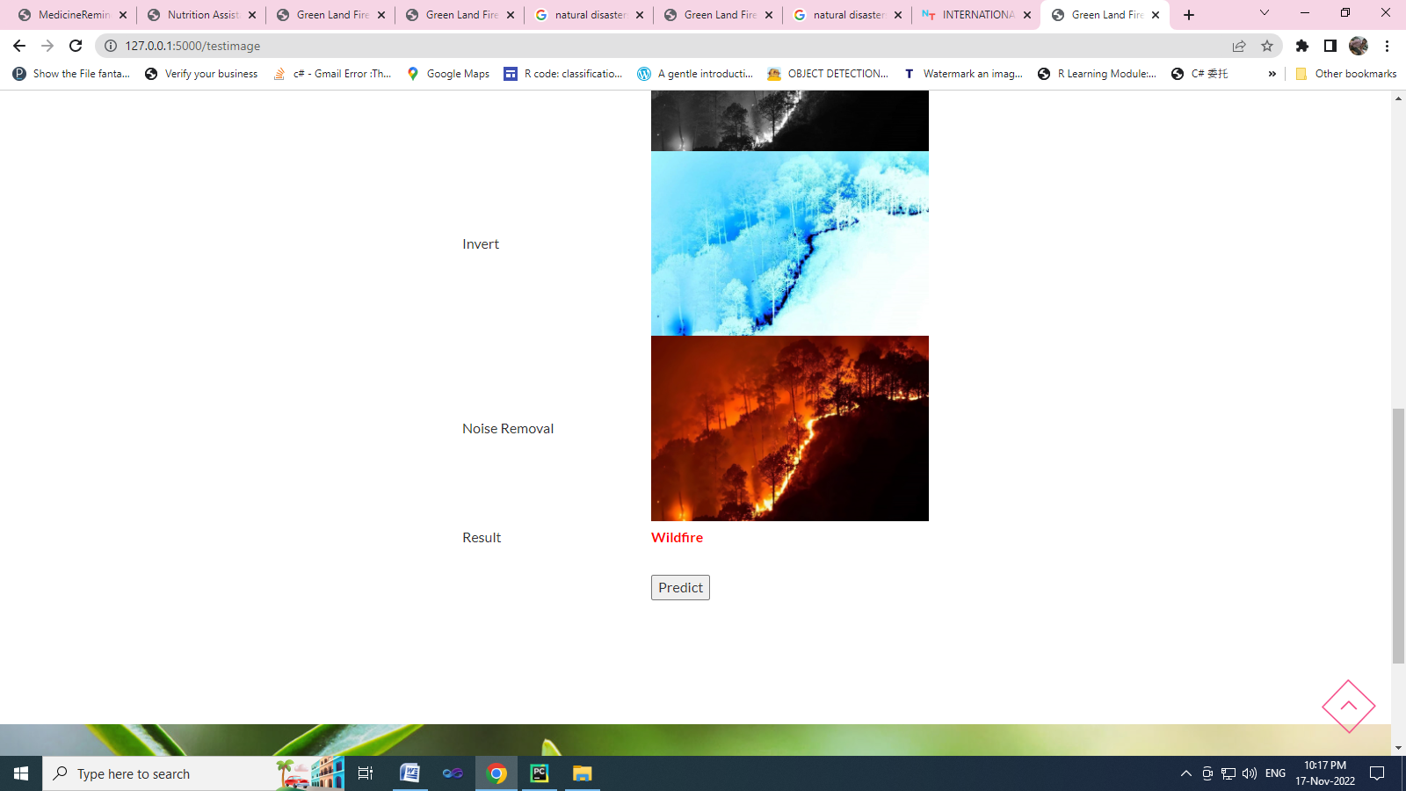

**GITHUB & PROJECT DEMO LINK**